Name: Class:
Introduction
This worksheet looks at two organic reaction pathways, and allows you to apply your knowledge of organic reactions to solve for ‘unknown’ compounds in these pathways.

No. | Question | Answer
The reaction pathway shown below leads to the production of organic compound G, propyl ethanoate. Complete the diagram by drawing structural formulas for compounds A to G, and writing the systematic name for each compound in the boxes provided.

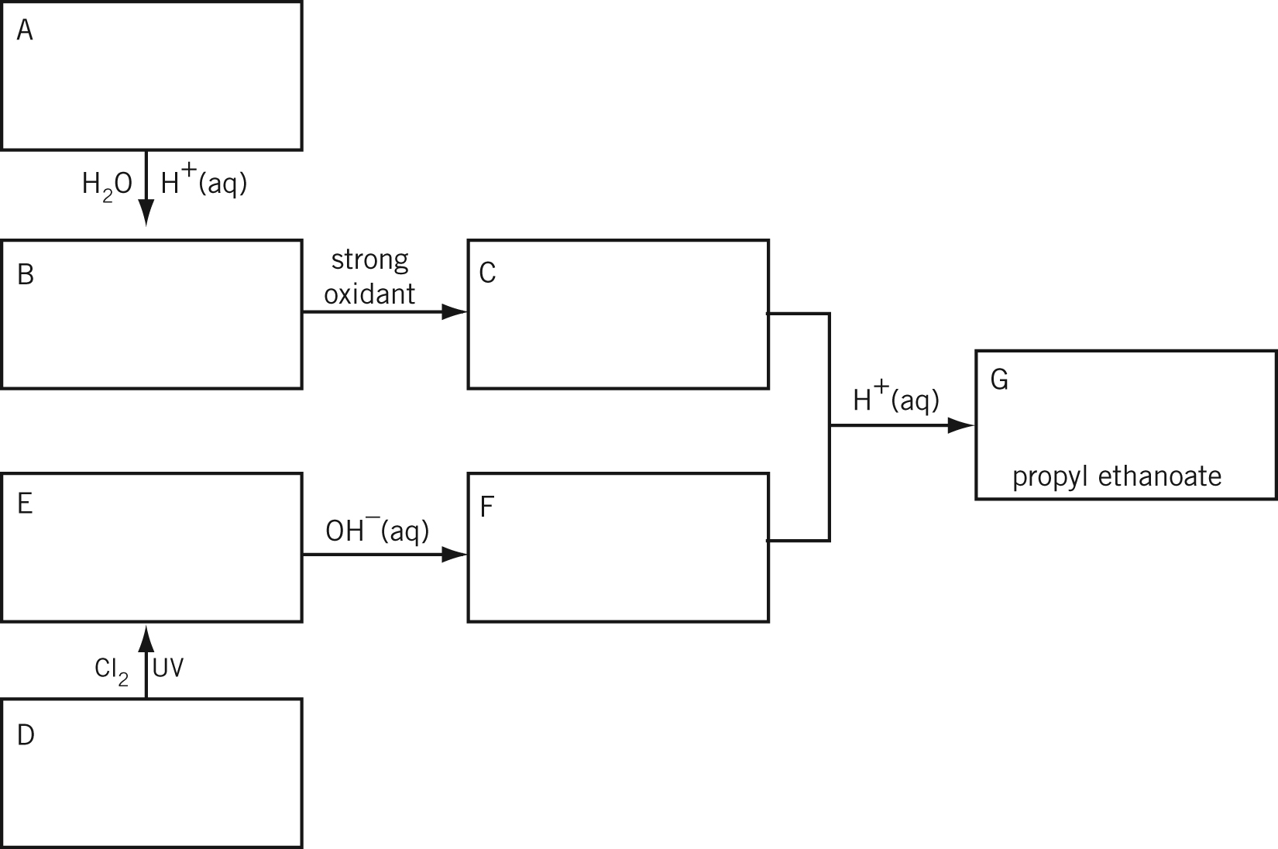

 | Describe a chemical test that could be used to distinguish between compounds A and D.
 | Describe a chemical test that could be used to distinguish between compounds C and G.
 | Which compound, B or F, would be expected to have the higher boiling point? Explain your choice.

Organic compounds H and I have the same molecular formula, C₄H₈. Compound H is reacted with HCl(g) and a suitable catalyst. Two organic products, compounds J and K, are isolated. Compound J undergoes reaction with OH–(aq) to produce compound L. Compound L is oxidised to produce compound M. Compound M undergoes reaction with Na₂CO₃(aq) to produce CO₂(g). Compound I also reacts with HCl(g) and a suitable catalyst to produce a single organic product, compound K. In another reaction, compound I undergoes addition polymerisation to form organic compound N.

No. | Question | Answer
 | What is the general name given to compounds H and I?
 | What does the reaction of compound M with Na₂CO₃(aq) suggest about compound L?
Complete the diagram below by drawing structural formulas for compounds H to N, and writing the systematic name for each compound in the boxes provided.

